Internet service providers to compare are cable and fiber. Cable uses existing cable tv lines to provide bandwidth for internet access. Speeds of cable internet service providers are much faster than those provided by Digital Subscriber Line or DSL. The bandwidth of all users is shared in the same area as a neighborhood and actual speeds may be much less than the maximum (TestOut, 2022). Fiber internet service providers provide internet access through light signal transmitted to the end user by way of fiberoptic cables. The speed of fiber ISP are much faster than those provided by any other form of connection. The downfall is how expensive the fiber is and how time consuming the job can be because of the fragile fiber optic cables (TestOut, 2022). Cable security according to (NCTA, 2021) is good for IoT (Internet of Things) technology such as a light bulb being attacked to criminals attacking compromising healthcare equipment. The security of fiber ISPs is better because of the way it transmits its data by way of pulses of light across very thin strands of glass or plastic fiber (Charter Communications, 2019).

The reliability of cable ISPs is good if there is a storm but due to cable internet being connected by areas or neighborhoods you can get slow internet connections. Fiber ISPs are good for reliability because of the way they transmit data. The only way connection is lost is if a severe storm manages to wreak the ground because in this environment fiber optic cables should be placed underground for protection. Also, if the power goes out the fiber is still working which can let you still access the internet if the router has a backup generator to power it on (Goldman, 2021).

The fiber ISP meets the business goals and objectives of the location. Fiber is the fastest connection speeds, which will help when streaming live video teleconferencing calls and if the power goes out you can still send print jobs to billboard printers located in the company headquarters in Albany.

A hardware solution would be to have device metrics to help the IT department to troubleshoot problems. By checking CPU utilization, hard disk utilization, memory utilization, and temperature inside the computer. A hardware solution would be NIC teaming configured in a switch independent for fault tolerance. This will help make certain that if one NIC fails the other will take over to remain accessible on the network (TestOut, 2022). A hardware solution would be a load balancer to separate the workload between two or more computers which allows you to have higher resource utilization, throughput, and response time (TestOut, 2022). A surge protector is great for protecting equipment damage by preventing overvoltage situations (TestOut, 2022). A generator can help by providing backup power for an extended period, normally between 24 and 48 hours (TestOut, 2022). Multipathing is a fault-tolerance technique to help CPU and mass-storage appliances by giving two paths between them (TestOut, 2022).

For software solution network performance could help by measuring the bandwidth utilization, error rate, and latency. For software log file management log messages should be used. These help with timestamp of incident which indicates when the message was created. Facility for which facility created the message such as “lpr” for printer subsystem (TestOut, 2022). Severity level for how serious the incident is. Mnemonic to help admins know the nature of the message. Message text to describe the event. Interface reset which indicates the number of times an interface has been completely reset. This happens if packets queued for transmission were not sent within several seconds. A packet sniffer is software that will capture records frames transmitted on the network (TestOut, 2022). A throughput tester can help test UDP by knowing if the bandwidth is below what it needs to send data. This device sends a specific amount of data through the network and measures the time it takes to transfer that data which gives the IT team the bandwidth measurement. Network interface monitor helps users know why their internet is slow by identifying the root cause of performance issues and network bottlenecks (TestOut, 2022). Finally, remote desktop protocol for VPNs (Virtual Private Network) to gain access to the network infrastructure to do their jobs effectively. Also, a packet analyzer to copy frames and view frame contents (TestOut, 2022). This also allows you to check for specific protocols on the network and check devices using restricted protocols (TestOut, 2022).

For printer configurations a wireless printer so that VPN (Virtual Private Network) employees can print from their remote locations. For printing from remote locations employees can use Google’s cloud print as remote employees only need to make a google account to use this. Another option is the new location can make a google account and share their printer with other employee accounts so that they can use the organizations printer. For tracking devices, you can use ThinPrint which is software that collects data on enterprise-wide printing activities and enters them into a SQL database (ThinPrint, 2022). IT admins can see this tracking and reporting website from anywhere and can adjust group management to make a group of users who use too much of the printing services or can import them into the active directory for a more detailed analysis (ThinPrint, 2022). The IT department can view trends of how the print volume has developed over time, distribution of which groups or users have printed the most and give an overview of the number of print jobs (ThinPrint, 2022). Thin print can track, automate drive distribution, and control access for users or groups by importing them into the active directory. Printer could also use driver updates provided by windows if the device is registered with Windows, it can do it automatically or can be turned off manually (TestOut, 2022).

Bandwidth for video conferencing should be 1.5 to 2.0 Mbps (Bell, 2021). The company should use 802.11ax for the best performance for their video conferencing and video streaming in high density environments. 802.11ax allows you to broadcast in more populated areas and can operate at 1 to 7.125 GHz range. Operating at 6 GHz allows more channels than operating at 5 GHz. Orthogonal frequency-division multiples access or OFDMA helps by making wireless channels into sub channels. It can divide a channel into 30 segments, assigning each segment a single device, and can send or receive signals at the same time (TestOut, 2022). 802.11ax has a technology called Basic Service Set Color or BSSC that the client transmits to identify them (TestOut, 2022). 802.11ax can help access points or APs by allowing them to function in the same radio frequency channel. Also, it can help with the latency between APs and wireless devices (TestOut, 2022). Finally, 802.11ax has a Target Wake Time or TWT. This technology can schedule a time for APs to communicate with devices at a certain time (TestOut, 2022). This solution provides devices with more channels to connect to while receiving or sending signals at the same time. Along with identifying clients by the color they transmit, allowing APs to function on the same radio frequency, and helps with latency between the devices and APs. TWT can help with large organizations that need constant connection for updates and activation (TestOut, 2022). Also, TWT helps by setting certain times for APs to communicate with devices.

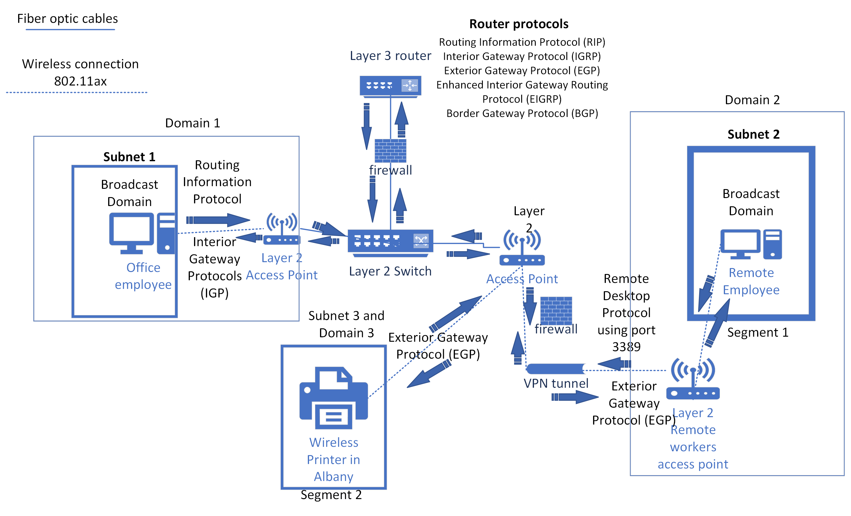

**References**

Bell, P. (2021, January 29). What Internet Speed do you Need for Video Conferencing? MegaMeeting. <https://www.megameeting.com/news/what-internet-speed-for-video-conferencing/#:~:text=Video%20conferencing%20typically%20requires%20around%201.5%20to%202>

TestOut. (2022). TestOut LabSim. Labsimapp.testout.com. <https://labsimapp.testout.com/v6_0_525/index.html/productviewer/1190/9.1.6/1159b9ea-e076-4320-9aed-f022b1465c53>

NCTA. (2021, October 29). How the Cable Industry Mitigates Cybersecurity Risks | NCTA — The Internet & Television Association. Www.ncta.com. <https://www.ncta.com/whats-new/how-the-cable-industry-mitigates-cybersecurity-risks#:~:text=Cable%20ISPs%20are%20leaders%20in%20helping%20to%20put>

Frontier. (2022). Is fiber-optic internet worth it for you? Frontier.com. <https://frontier.com/resources/is-fiber-optic-internet-worth-it>

Charter Communications. (2019). Why is fiber-optic communication technology more secure? | Spectrum Enterprise. Spectrum.com. <https://enterprise.spectrum.com/support/faq/internet/why-is-fiber-optic-communication-technology-more-secure.html#:~:text=Fiber-optic%20communication%20offers%20higher%20security%20because%20of%20the>

Goldman, K. (2021, January 26). How Will My Fiber Internet Perform in a Storm? <Https://Blog.frontier.com/>. <https://blog.frontier.com/2021/01/how-will-my-fiber-internet-perform-in-a-storm/#:~:text=W%20hat%20makes%20fiber%20reliable%201%20Fiber-optics%20is>

ThinPrint. (2022). Automated Print Management with ThinPrint Management Services. ThinPrint. <https://www.thinprint.com/en/features/management-services/>